Book

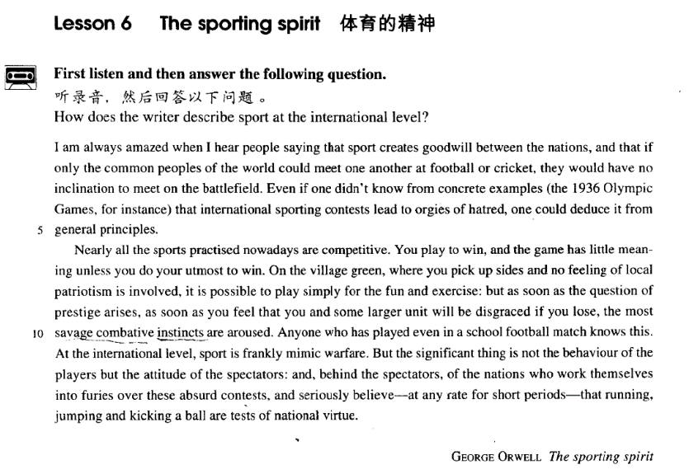

课文

I am always amazed when I hear people saying that sport creates goodwill between the nations,

我总是惊愕不已。当我听人们说体育运动可创造国家之间的友谊，

and that if only the common peoples of the world could meet one another at football or cricket, they would have no inclination to meet on the battlefield.

还说各国民众若在足球场或板球场上交锋，就不愿在战场上残杀的时候，

Even if one didn't know from concrete examples (the 1936 Olympic Games, for instance) that international sporting contests lead to orgies of hatred, one could deduce it from general principles.

一个人即使不能从具体的事例（例如1936年的奥林匹克运动会）了解到国际运动比赛会导致疯狂的仇恨，也可以从常理中推断出结论。

Nearly all the sports practised nowadays are competitive.

现在开展的体育运动几乎都是竞争性的。

You play to win, and the game has little meaning unless you do your utmost to win.

参加比赛就是为了取胜。如果不拚命去赢，比赛就没有什么意义了。

On the village green, where you pick up sides and no feeling of local patriotism is involved,

在乡间的草坪上，当你随意组成两个队，并且不涉及任何地方情绪时，

it is possible to play simply for the fun and exercise: but as soon as a the question of prestige arises,

那才可能是单纯的为了娱乐和锻炼而进行比赛。可是一量涉及到荣誉问题，

as soon as you feel that you and some larger unit will be disgraced if you lose, the most savage combative instincts are aroused.

一旦你想到你和某一团体会因为你输而丢脸时，那么最野蛮的争斗天性便会激发起来。

Anyone who has played even in a school football match knows this.

即使是仅仅参加过学校足球赛的人也有种体会。

At the international level, sport is frankly mimic warfare.

在国际比赛中，体育简直是一场模拟战争。

But the significant thing is not the behaviour of the players but the attitude of the spectators:

但是，要紧的还不是运动员的行为，而是观众的态度，

and, behind the spectators, of the nations who work themselves into furies over these absurd contests, and seriously believe -- at any rate for short periods -- that running, jumping and kicking a ball are tests of national virtue.

以及观众身后各个国家的态度。面对着这些荒唐的比赛，参赛的各个国家会如痴如狂，甚至煞有介事地相信 -- 至少在短期内如此 -- 跑跑、跳跳、踢踢球是对一个民族品德素质的检验。

词汇讲解

Lesson 6

**The sporting spirit**

goodwill [7gʊd'wɪl] n. 善意，友好，友好关系

exude goodwill promote goodwill create and strengthen goodwill goodwill games goodwill visit goodwill tour

President Obama is on a Middle East goodwill tour.

official visit

official goodwill visit informal visit

private visit state visit

President Xi Jinping is on a three-day official goodwill visit to Vietnam.

inclination [7ɪnklɪ'neɪʃn] n. 意愿

have an inclination to do sth.

I haven't the slightest inclination to become a journalist. incline be inclined to do sth.

Be careful not to annoy the boss, because he is inclined to lose his temper. because he tends to lose his temper.

because he has the tendency to lose his temper. because he is apt / prone to lose his temper.

Lesson 6

**The sporting spirit**

goodwill [7gʊd'wɪl] n. 善意，友好，友好关系

exude goodwill promote goodwill create and strengthen goodwill goodwill games goodwill visit goodwill tour

President Obama is on a Middle East goodwill tour.

official visit

official goodwill visit informal visit

private visit state visit

President Xi Jinping is on a three-day official goodwill visit to Vietnam.

inclination [7ɪnklɪ'neɪʃn] n. 意愿

have an inclination to do sth.

I haven't the slightest inclination to become a journalist. incline be inclined to do sth.

Be careful not to annoy the boss, because he is inclined to lose his temper. because he tends to lose his temper.

because he has the tendency to lose his temper.

because he is apt / prone to lose his temper. contest ['kɒntest] n. 比赛a speech / beauty / dance contest

game / match

a boxing / basketball / football / volleyball match / game

games

the Olympic Games race

a car / boat / horse / swimming race open

tournament championship

deduce [dɪ'dju:s] v. 推断

deduce A from B

deduce effect from cause deduction

conclude A from B conclusion

infer A from B

What can we infer from the passage?

inference

patriotism

['pætriətɪzəm] ['peɪtriətɪzəm]

n. 爱国主义

“patr” = “pater”: father patriot

patriotic patriotic songs / education

patriotism compatriot

patriarchy patricide

paternal paternal affection paternity He is on paternity leave.

“matr” = “mater”: mother

matriarchy matricide

maternal maternal affection maternity She is on maternity leave.

disgrace [dɪs'greɪs] v. 使出丑，使丢脸

The dishonest minister was publicly disgraced.

shame … humiliate …

bring shame on … bring disgrace on …

His behavior

disgraced shamed

humiliated his family.

brought shame on brought disgrace on

show sb. up

Mary’s boyfriend showed her up by falling asleep at the concert.

mimic warfare ['mɪmɪk 'wɔ:feə(r)] n. 模拟战争

chemical warfare nuclear warfare germ warfare

guerrilla warfare

mimic warfare mimic coloring mime

I am always amazed when I hear people saying that sport creates

goodwill between the nations, and that *if only the common peoples of the*

*world could meet one another at football or cricket,* they would have no

inclination to meet on the battlefield. amaze sb.

When the archaeologists reconstructed the fragments, they were amazed to find that the goddess turned out to be a very modern-looking woman. amaze sb.

surprise sb. astonish sb.

He was astonished at what he found. A man was lying in the box on top of a pile of woolen goods.

amaze sb. surprise sb. astonish sb.

astound / dumbfound sb.

The police were astounded when Mrs. Ramsay told them what she had done.

I am always amazed when I hear people saying that sport creates

goodwill between the nations, and that *if only the common peoples of the*

*world could meet one another at football or cricket,* they would have no

inclination to meet on the battlefield.

If only I *were* as clever as you are!

If only they were here now, we would be able to celebrate their wedding anniversary.

only if …

She will go only if Peter goes. Only if Peter goes *will* she go.

Even if one didn't know from concrete examples (the 1936 Olympic

Games, for instance) *that international sporting contests lead to orgies of hatred*, one could deduce it from general principles.

even if … / even though …

Even though you dislike ancient monuments, Warwick Castle is worth a visit.

Even if you dislike ancient monuments, Warwick Castle is worth a visit. solid / concrete

solid / concrete examples / conditions

abstract

Beauty itself is abstract.

The 11th Olympic Games in Berlin, when Adolf Hitler was in authority

It was a historical mistake. The Nazi government saw the Olympics as a golden opportunity to promote their fascist ideology, that was to purify and strengthen the Germanic Aryan population.

Hitler wanted to take advantage of this opportunity to advertise the blond hair, blue-eyed Aryan racial superiority.

Ironically, American black athlete Jesse Owens was the star of the 1936 Olympic Games, who won 4 gold medals.

This made Hitler disgraced and increased his hatred towards other nations.

orgies of … / an orgy of …

疯狂的……；过度的……

orgies of hatred an orgy of killing

an orgy of spending before Christmas

binge / spree

He went on a drinking binge over the weekend. The girls went on a shopping spree on Saturday.

practise / practice v. 经常做，从事

practice n. 习俗，惯例

On the other hand, your stomach would turn at the idea of frying potatoes in animal fat—the normally accepted practice in many northern countries.

do / try one’s utmost to do do / try one’s best to do

Though the doctor did his best, the patient's recovery was slow.

go to great lengths to do

The man went to great lengths to prove that the diamonds were real. endeavor / endeavour to do

We endeavour to avoid the old, romantic idea of a gusher, which wastes oil and gas.

spare no effort to do

China will spare no effort to realize peaceful reunification.

give one’s all to do go all out to do

They should wait for John to bring the dessert.

He thinks John must have spent a lot of money for the dinner.

The dessert also looks impressive.

He helped John make the sandwiches.

W: Look at the delicious sandwiches. John’s really gone all out this time. M: Just wait until you see the dessert.

Q: What does the man imply?

Answer: (C) The dessert also looks impressive. Part 1 of the movie was amazing.

Just wait until you see Part 2. Part 2 is even better

On the village green, *where you pick up sides and no feeling of local*

*patriotism is involved*, it is possible to play simply for the fun and exercise: but as soon as the question of prestige arises, as soon as you feel

that you and some larger unit will be disgraced *if you lose*, the most savage combative instincts are aroused.

question of prestige question of pride

It is a question of pride as much as anything else. question of time

She is so talented and diligent that her success is only a question of time. matter of …

Education in the wilderness is not a matter of monetary means. It’s only a matter of time.

It’s a matter of personal taste.

It’s a matter of preference. It’s a matter of interest.

It’s a matter of life and death.

I can’t take the money. It’s a matter of principle.

arise arose arisen arise from …

The conflict arose from tensions between different ethnic groups.

unit n. group; organization

arouse interest / hostility / resentment

germ / jungle / nuclear / chemical / guerrilla / psychological warfare

But the significant thing is *not* the behaviour of the players *but* the attitude of the spectators: and, behind the spectators, (?) of the nations who work themselves into furies over these absurd contests, and seriously believe*—at any rate for short periods—*that running, jumping and kicking

a ball are tests of national virtue. not … but … 不是……而是…… not that … but that …

不是因为……，而是因为……

Not that I love Caesar less, but that I love Rome more.

— Shakespeare ‘Julius Caesar’

Not that I love you less, but that I love liberty more.

Not that I love my teacher less, but that I love truth more.

It is not that … but (that) …

不是因为……，而是因为……

It was not that I actually remembered anything at all. But my father had

described over and over again what we should see at every milestone, after leaving the nearest town …

It is not that the scales in the one case, and the balance in the other, differ

in the principles of their construction or manner of working; but that the

latter is a much finer apparatus and of course much more accurate in its

measurement than the former.

spectator audience viewer

onlooker / looker-on

It is … that / who …, not …

It is older people who create it, not the young themselves.

It is the attitude of the spectators that is significant, not the behavior of the players.

It is the attitude of the spectators that is significant / that is of significance, not the behavior of the players.

It is the attitude of the spectators that is significant / that is of significance

/ that matters / that counts, not the behavior of the players. It is the thought that counts.

work sb. into …

He worked himself into a rage.

He worked his audience into enthusiasm. at any rate 1. 无论如何

= in any case / event

= come what may

~, we must go on Tuesday. at any rate 2. 至少

= at least

They felt, or ~ Dan felt, both relieved and frightened.

For example, Hitler saw the Olympics as a test of the Aryan racial superiority.

But the author argue that sport is only for sport; it has nothing to do with prestige or national virtue and it won’t create goodwill between the

nations.